**How to configure R Studio Project with Github.**

Sometimes it can be overwhelming to handle a large number of code files in the working directory. For example- data.R, data1.R, data2.R, ...

**Git,** a version control system and **Github**, its web based analog,  allow you to track all your changes that you made with your R code and keep them in one file.

Below are the steps needed to set up R Studio with Git and Github.

1.      Download and install [R Studio](https://www.rstudio.com/).

2.   Setup a GitHub account. Create public repository on GitHub. The instructions are [here](https://help.github.com/articles/create-a-repo/).

3.      Download and install the [platform-based version of Git](https://git-scm.com/) desktop. Configure Git desktop with default options.

4.      Open Git bash and type the following global commands:

a)      git init.

b)      git config –global user.name “your Github account name”

c)      git config –global user.email [YourGithub@xxx.com](https://mg.mail.yahoo.com/neo/b/compose?to=YourGithubEmail@xxx.com)

The first command in step 4 initializes an empty local Git repository on your computer, parallel to the folder containing all the working files. The second and third commands create a user account using an email in order to associate it with GitHub repository on the Web. These steps are necessary to start tracking any changes in your code files. It will not work without a user account.

5.      In R Studio select Tools > Global Options > Git/SVN and check "Enable version control interface project…” (RStudio 1.0.36). Also, verify the path to Git.exe is correct.

6.      Go to File > New Project > Version Control > Git > Clone Git Repository.

The screenshots can be seen [here](https://support.rstudio.com/hc/en-us/articles/200526207-Using-Projects). In the Repository URL box, cut and paste the URL in the created GitHub public repository. The link will appear if the “Clone or download” button is selected, as it is shown in the screenshot.

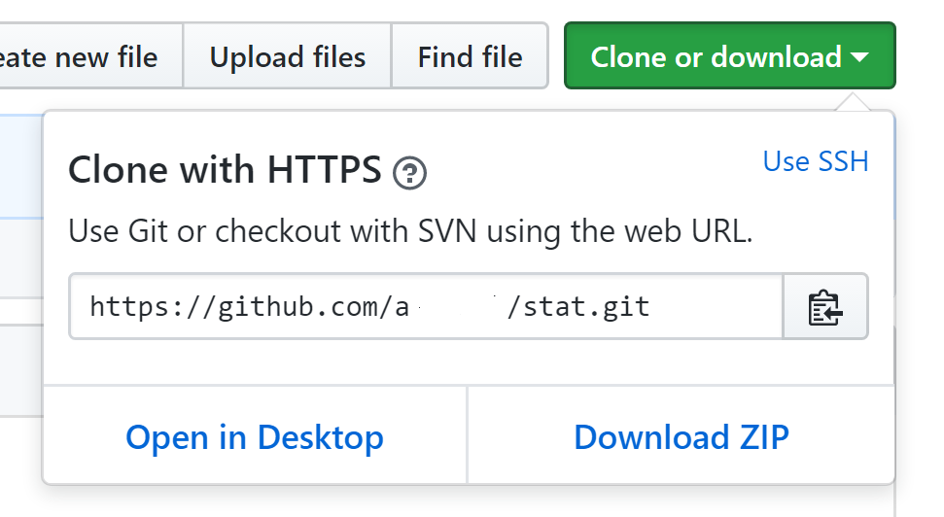

Locate the project directory in the same “Clone Git Repository” box. After performing these steps the new Git tab will appear in the upright R Studio window.

Since git executable has already installed in in RStudio IDE of [Datascienceworkbench](https://my.datascientistworkbench.com/tools/rstudio-ide/) to get it working you just need to open shell from R Studio (Tools > Shell) and repeat Steps 4, 5 and 6.

Tracking changes in your code is now possible with the “Commit”, “Pull” and “Push” buttons on the Git tab. Another blog post will detail the functions and operations of these buttons.